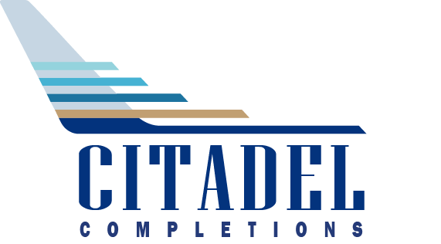

|  |  |  |
| --- | --- | --- |
| To: | David Feuerhak  Cabin Management Solutions 2971 Hawthorne Drive  Conroe,Tx. 77301  email  936-523-1700 | Date: **01/15/24**  Project Number: **P7398**   RFQ Number: **7398011524CMS** |

Citadel Completions LLC (“Citadel Completions”) From: 3900 Chennault Parkway   
 Lake Charles, LA 70615

|  |  |
| --- | --- |
| Subject: **Replacement CMS System on 737-700IGW** | Request for Quote (RFQ) – Services |

|  |  |
| --- | --- |
| Type of Contract: | **FFP** |
| Questions/Comments must be submitted by: | **01/16/24** |
| RFQ to be Returned NLT: | **ASAP** |
| Date to AwardContract timeframe: | **Q1 2024** |

**Statement of Work (SOW):**

|  |  |  |
| --- | --- | --- |
| |  |  | | --- | --- | | 1.  2.  3.  4.  5.  6.  7.  8.  9.  10. 11. | Citadel Completions requests Cabin Management Solutions (CMS) to provide Firm fixed Pricing of replacement of existing Collins CMS System with Cabin Management Solutions, Evolve Cabin Management System on Boeing B737-700IGW MSN 29749, Reg. N888TY.  Citadel Completions requests Cabin Management Solutions (CMS) provide optional pricing for their CMS Explore 4K Moving Map System.  Citadel Completions requests CMS Solutions refers to Quotation CMS-20231206-01 Rev. 1 for reference and sign and return this RFQ form.  A Mutual Confidentiality Agreement must be fully executed by the Parties prior to any disclosure of such defined Confidential Information.  **Note:** All communications shall be through Citadel Completions and Project specifics shall be communicated through the designated Citadel Completions Point of Contact (“POC”) only.  Citadel Completions requests Cabin Management Solutions provide all approvals with the completed documentation (As required).  Citadel Completions requests Cabin Management Solutions provide all required Test plans and reports, analysis, substantiation, assessments etc.  Citadel Completions assumes return to service under -337, unless otherwise specified.  Citadel Completions requests Cabin Management Solutions Provide payment terms and lead time to be provided with pricing.  Citadel Completions requests a separate line item for shipping from Cabin Management Solutions manufacturing facility to Citadel Completions, 1945D Merganser Street, Lake Charles, LA 70615 Any travel relating to this RFQ must be approved by Citadel Completions’ POC or in accordance withCitadel Completions’ Travel Policy. | |

Page 1 of 4 | Vendor Initials ______ Citadel Completions LLC. Confidential Information.



|  |
| --- |
|  |

**Citadel to Provide:**

|  |  |
| --- | --- |
| Engineering Drawings: |  |
| Decorative Finish Schedule: |  |
| Illustrations/Renderings: |  |
| Specifications: |  |

**VENDOR WORK SCOPE PRICING MATRIX:**

|  |  |  |
| --- | --- | --- |
| **Effort** | **Task Reference or Description of Work** | **Price** |
| CMS Installation Parts and NRE | Quotation CMS-20231206-01 Rev. 1 Item 1 | $904,385.00 |
| CMS Explore Parts | Quotation CMS-202311206-01 Rev 1 Item 2 | $71,405.00 |
|  |  |  |
|  |  |  |
|  |  |  |
| **TOTAL COST:** | | $975.790.00 |

**Vendor Turnaround/ Lead Time:**

|  |
| --- |
|  |

**Vendor Payment Terms**

|  |
| --- |
| See quotation CMS-20231206 Rev 1 for Details |

**Vendor Comments/Notes:**

|  |
| --- |
|  |

Page 2 of 4 | Vendor Initials ______ DCF Citadel Completions LLC. Confidential Information.



**RFQ RESPONSE NOTICE**

**Citadel Completions LLC will ONLY accept a RFQ response via this form. Response or submission provided to Citadel Completions LLC in any format other than via this form will be disqualified from vendor selection at award of the contract.** This document must be signed and submitted to be deemed responsive. The undersigned guarantees the truth and accuracy of all statements and the information provided herein.

**Quote Validity:** 120 days.

**REQUEST FOR QUOTE (RFQ) DISCLAIMER**

This RFQ represents only a definition of requirements. It is merely an invitation for a voluntary submission of quotes and does not legally obligate Citadel to accept any of the submitted quotes in whole or in part, nor is Citadel obligated to select the lowest priced quote. Citadel is not responsible for any costs associated with a Service Provider’s preparation and submission of a quotation, regardless of the outcome or the manner of conducting the selection process. Nothing in this RFQ shall be construed to create any legal obligation on the part of Citadel.

Unless a Master Services Agreement is executed by and between the parties, all Goods and Services purchased shall be governed by Citadel’s Terms and Conditions available at

<http://www.citadelcompletions.com/TsAndCs.pdf>

and no addition or variation to these Terms and Conditions will have any effect unless expressly agreed to in writing by Citadel.

If this RFQ/Order is for an aerospace application, in addition to Citadel’s General Terms and Conditions, your organization agrees to meet the following stipulated AS9100 / AS9110 requirements available at:

<http://www.citadelcompletions.com/QualityTsAndCs.pdf>

Page 3 of 4 | Vendor Initials ______ DCF

Citadel Completions LLC. Confidential Information.

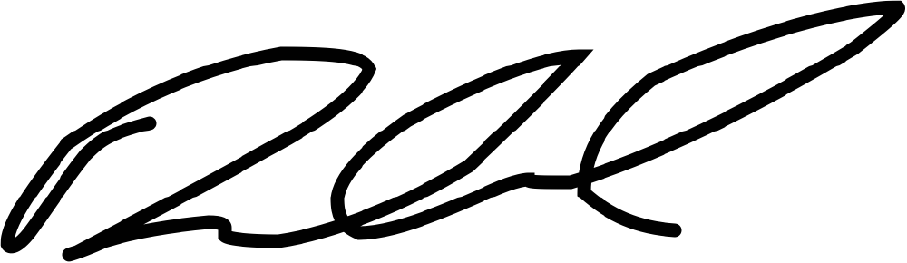



**Request for Quote Prepared and Authorized by:**

Name: Dexter D. Sternberg   
Title: Engineering Project Lead   
Contact Number[: 337-263-4893](mailto:dsternberg@citadelcompletions.com)   
E-Mail Address: [dsternberg@citadelcompletions.com](mailto:dsternberg@citadelcompletions.com)   
Date: 1/15/24

**Response to Quote Prepared and Authorized by:**

Signature: ________________________________________________ Date: __________________ 1/15/2024

Name: ___________________________________________________ Title: __________________ David Feuerhak VP of Sales

Page 4 of 4 | Vendor Initials ______ DCF

Citadel Completions LLC. Confidential Information.